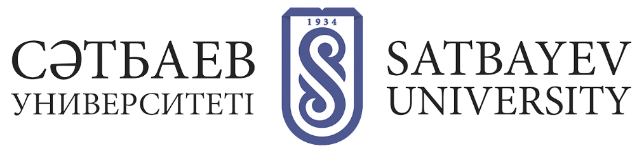

SCIENTIFIC LIBRARY

Scientific library of Satbayev University was founded on September 22, 1934 on the basis of Semipalatinsk Geological-Exploration Technical School library with the original stock of about 1000 copies. Currently the library has about 2 million copies of scientific and technical literature, including rare geological and mining publications of the famous explorers V.K. Monich, K.G. Voynovsky-Krieger, A.V. Brichkin, scientific works of scientists K.I. Satpaev, A. Mashani, O.A. Baykonurov and new books of the world famous publishing houses.
Today the library of Satbayev University is the information and cultural-educational center of the university, a source of educational and scientific information for teachers and students. The library infrastructure consists of 4 departments. Readers' service is provided in 15 service points: 8 subscriptions and 7 reading rooms. All the reading rooms are equipped with modern computer equipment. At the present time the library serves more than 7 thousand readers.
According to the requirements for the information support of the scientific and educational activity of the University the library fund is constantly replenished with new editions. Every year license agreements are concluded for subscription to the databases of leading publishing houses, universal and thematic electronic collections of the universities in the directions of educational programs and priority topics of scientific projects and innovative developments of the university. The university provides the students, teaching staff and scientific workers with the access to the subscription foreign databases and electronic books of the leading publishing houses Elsevier, Springer, Wiley, Ebsco, scientometric databases provided within the national license (WoS, Scopus), EBS IPR books and LAN, and also demanded electronic libraries in Kazakh and Russian languages.
A great place in the activity of the Scientific Library is the support of the research work of scientists. The library workers render the constant consulting help to researchers on the questions of use of the international databases of scientific citation, work with the author's profiles, increase the skills of academic writing, carry out monitoring of the publication activity, etc. In order to support the improvement of users' information culture, the library systematically organizes trainings, webinars, master classes and practical sessions on working with databases, new technologies and services.
In the library is implemented an innovative, modern AIBS "MegaPro", which allowed to automate all production processes of the library: acquisition and book supply stock, creating and maintaining databases, the service readers online, etc. The library forms and develops the University Electronic Library, which has about 20,000 documents.
The Scientific Library is the leader among the universities' libraries by the volume of documents, transferred to the Republican Interuniversity Electronic Library (RIEL).
The scientific library of Satbayev University is an active member of the Association of libraries of higher educational institutions of the Republic of Kazakhstan, the methodological center for the libraries of technical universities and colleges of Almaty city and Almaty region.

