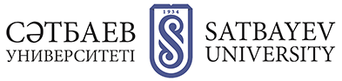

APPLICATION FORM
FOR REGISTRATION FOR PARTICIPATION IN THE CONFERENCE "DEVELOPMENT OF THE MINING AND METALLURGICAL COMPLEX OF KAZAKHSTAN FOR THE IMPLEMENTATION OF THE STATE INVESTMENT PROJECT" Surname, name, patronymic;

Section name:
Title of the report:
Surname, name, patronymic of the co-authors of the report:
Place of work (full name of organization, university, department):
Job title:
Academic degree and academic title:
Address (with zip code)
Contact phone number +7 (727)
E-mail:
Participation form:
- Oral report at the plenary session, publication of the report in the collection
- Oral presentation in sections, publication of the report in the collection
- Publication of the report
Hotel booking
The time limit for speaking at the plenary session is 15 minutes;
sections - 10 minutes.

