**Instructions for online application for accommodation in the dormitory of Satbayev University students**

* 1. **Prepare the necessary documents**
* Passport or ID card
* Additional documents confirming the right to an extraordinary or priority provision of a place (for example, a certificate of disability, a certificate of low income, etc.)
  1. **Get a username and password on Admissions** **Committee’s** **website**
* Go to Admissions Committee’s portal <https://kb.satbayev.university/>
* In "Place of residence" section, answer the question whether you need a hostel, pre-select the priority and click on "Apply" button.

**3.** **Submit an online application for a hostel**

* Log in to the Dormitory <https://dormitory.satbayev.university/>
* Fill in all required fields in the electronic form. Make sure that the entered data is correct.

**4. Submitting the online application step by step:**

In order to apply for accommodation in the dormitory through Dormitory system, follow these steps:

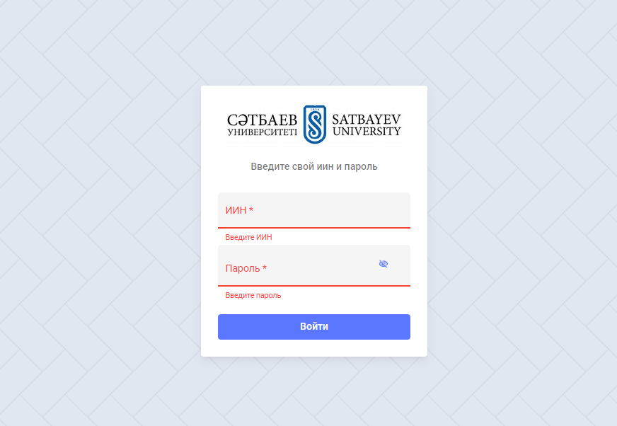

1. **Go to the website and log in**

Follow the link <https://dormitory.satbayev.university/>. Enter the username and password you received when registering at Admissions Commission, or use the corporate username and password issued to log in to SSO educational portal.

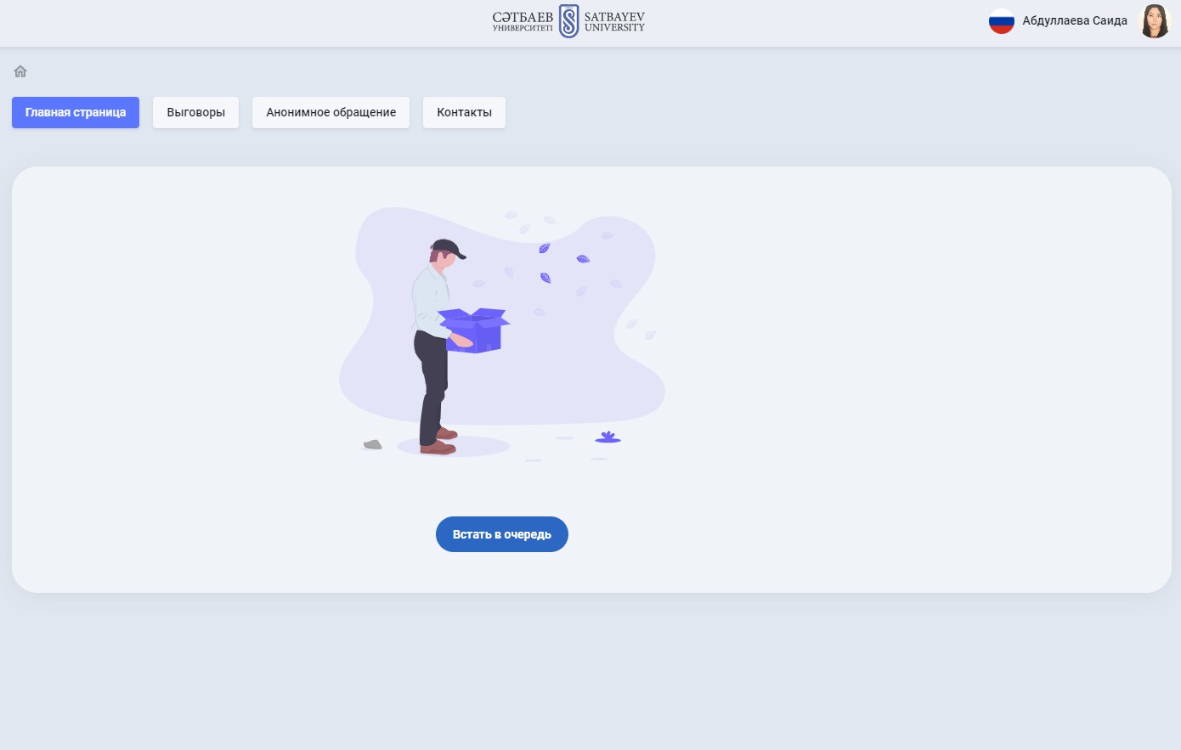

1. **Personal account**

After successful authorization, the page of your personal account in the Dormitory system will open. Here you can track the status of your queue for a place in the hostel. To apply, click on **“Get in the queue”** button.

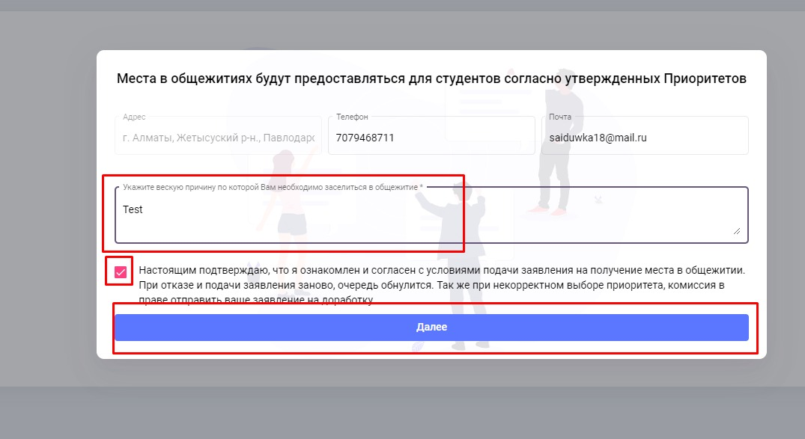

1. **Filling in the data**

In the modal window that opens, enter the current data: phone number, email, comment (if required), and agree to the processing of the data by checking the appropriate box. After that, click **"Next" button**.

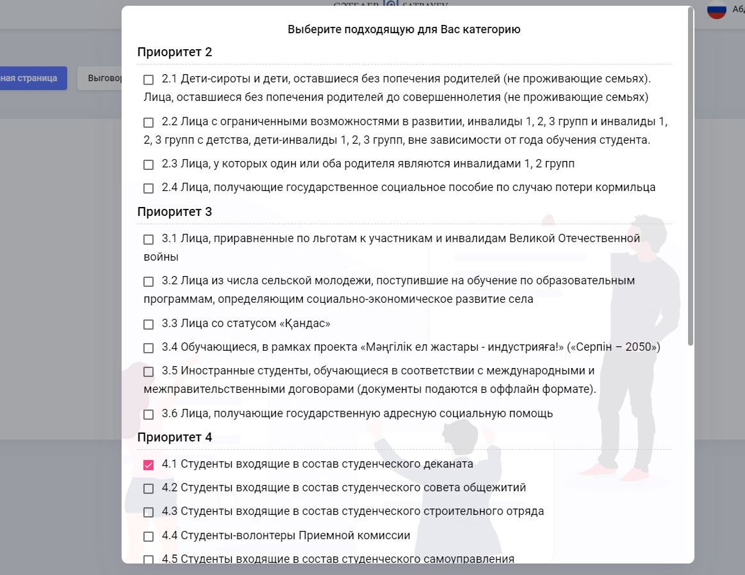

1. **Priority selection**

In the next step, select the priority item for check-in. If you do not belong to any of the suggested priorities, select Priority 8.1. Click **"Next"** button to confirm the selection and continue filling out the form.

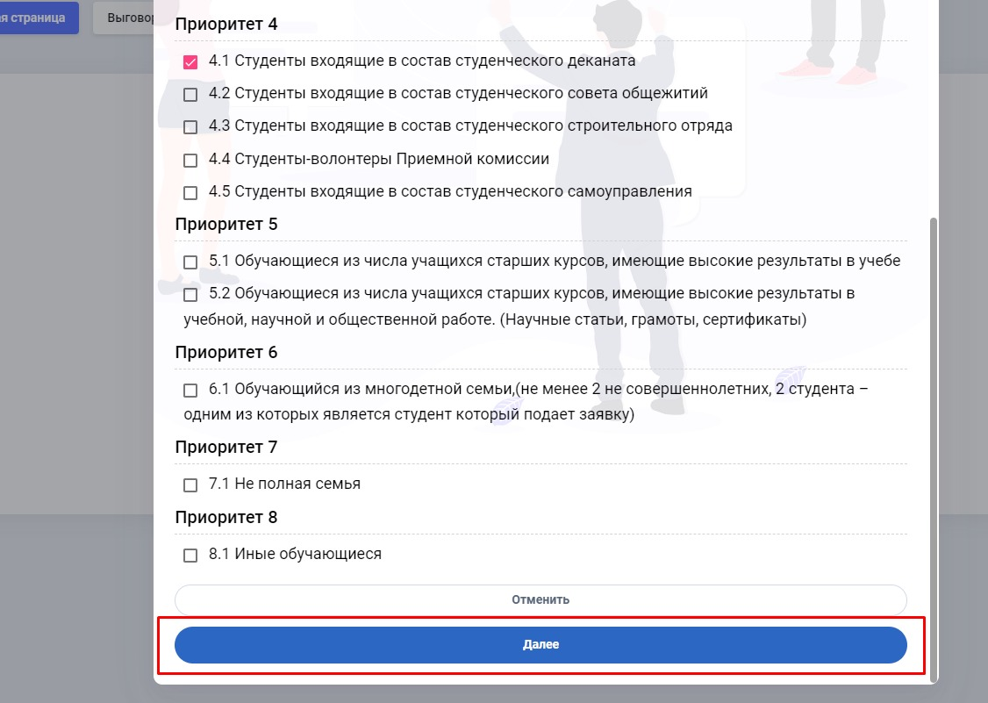

1. **Attaching the documents**

Attach the supporting documents corresponding to the selected priority. The documents must be original, of good quality, in the allowed formats (.jpg, .jpeg). After attaching the documents, click **"Next"** button.

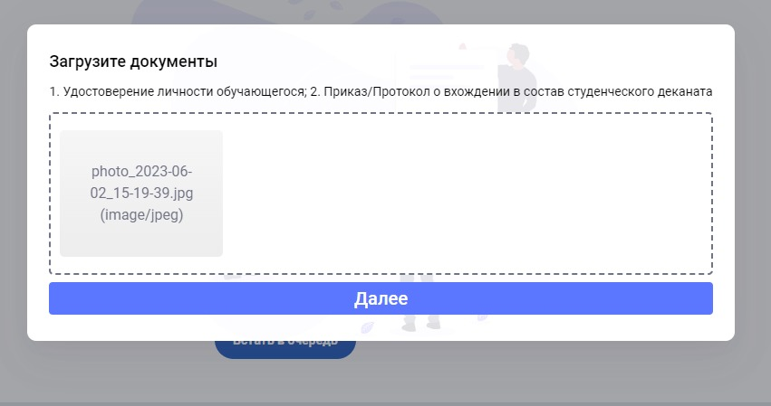

1. **Tracking the application**

After filling out the application, you will be able to track the progress of your queue to check into the hostel. If the status of your application changes, the system will send a notification to your email address. The final approval of the application will also be accompanied by a notification.

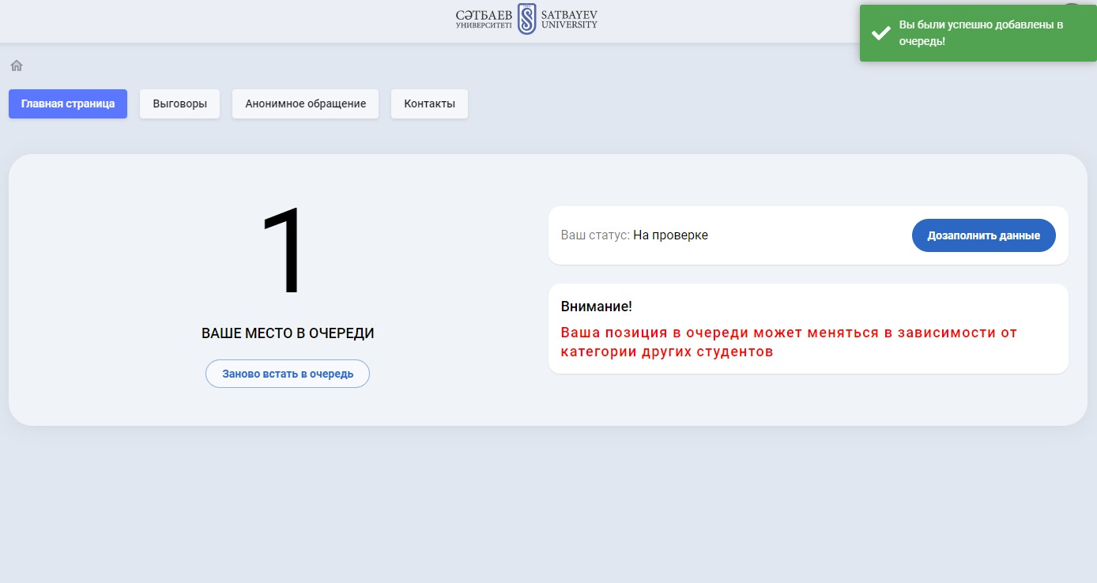

* **Receive notification related to the decision**

After reviewing the application, you will receive a notification of Commission’s decision on allocating the places in the hostel. It may contain information about the provision of a place, refusal or inclusion in the waiting list.

* **Check-in**

After receiving the notification of approval of the application, you will receive detailed instructions on the date and time of check-in, the necessary documents and payment.

* **Payment**

Pay for your stay according to the established rates and deadlines. Payment information will be available on the portal or in the notification. Also, after changing the student's status to "Settled", it will be possible to scan the QR code in your personal account and pay for accommodation in the hostel through Kaspi Gold or Halyk

* **Familiarization with the accommodation rules**

On the day of check-in, read the rules of accommodation in the hostel and sign the agreement.

**Important!**

Follow all deadlines and requirements specified in the notices and instructions. Failure to comply with the conditions may result in the refusal to provide a place.