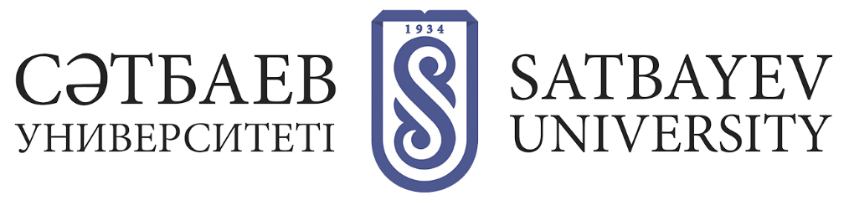

Organization of the educational process using Blended Learning technology

Blended Learning is an educational concept in which a graduate student learns both independently online and face-to-face with a faculty member. Blended Learning (hereinafter - BL) is an opportunity to combine traditional methods and current technologies.
The BL technology is not an independent separate form of education, but only complements and supports the legally established forms of education.
Organization of educational process in the format of blended learning (BL) is carried out with the use of individual distance learning technologies without excluding the traditional forms of face-to-face educational interaction between the teacher and students
During the theoretical training in the format of blended learning learning learning courses are carried out through contact hours with teachers, through an electronic system of distance learning and personal learning environments, where the learner is provided with all training materials (lecture notes, video lectures, presentations), assignments (tests, written assignments, collective discussion).
The Department of Graduate Studies and the corresponding institute ensure the organization of training with the use of BL technology at the University.
The decision to allow the student to study using BL technology is taken by the Vice-Rector for Science and International Cooperation in the presence of the consent of the head of the relevant department, the director of the relevant institute, as well as supporting documents.
To receive education using BL technology, the student must submit an application to the Vice-Rector for Science and International Cooperation in the form according to Appendix 2 to the "Regulations on the use of Blended Learning (Master's and Doctoral Programs)", as well as obtain the consent of the Head of Department and the Director of the Institute. When transferring to training with the use of BL technology, the students who are employed in the regions of Kazakhstan and Central Asia, as well as students working on a rotational basis, must provide a certificate from the place of work, students with disabilities certificate of the CWC on disability and/or the presence of physical restrictions, confirming the inability of the student to attend classes at the University.
Transfer of the learner to training with the use of BL technology is formalized by order of the Vice-Rector for Science and International Cooperation. The order is issued by the Department of Postgraduate Education.
Graduate students who choose to study using BL technology are given the opportunity to study in 0/0/100 format.
Graduate students must inform the department of their choice of the 0/0/100 format prior to the beginning of the theoretical course (academic period).
The 0/0/100 learning format provides for online learning during the semester and includes the student's fulfillment of all requirements on the part of the instructor:
- perform assignments according to the approved syllabus for each discipline (the learner who agrees to study according to this format is obliged to provide the instructor with the completed assignments)
- submit all assignments according to the syllabus by the end of each grading week;
0/0/100 result: pass the final exam in offline format in the period according to the approved academic calendar according to the results of two attestations.
Learners are allowed a flexible schedule of delivery of set assignments according to the syllabus before the session, and the delivery of set assignments is - compulsory.
Independent viewing of lectures and other types of classes on educational platforms is possible.

