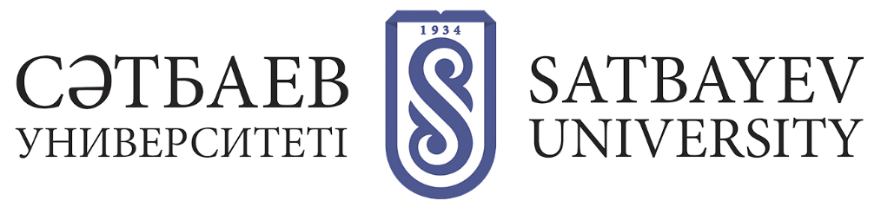
Contacts of institutes and names of educational programs

Institute of Geology and Petroleum Engineering named after K.Turysov
Institute Directorate: Main academic building, Auditorium 325, 8 (727)
320 40 31, 8 (727) 292 79 62.
Director Syzdykov Askar Khamzaevich
Deputy Director Narbayev Mars
Educational programs:
8D07205 Geology and exploration of deposits of solid minerals;
8D07206 Geology of oil and gas;
8D05202 Hydrogeology and Engineering Geology;
8D07202 Petroleum engineering;
8D07104 Petroleum and ore geophysics;
8D07109 Innovative technologies and new inorganic materials;
8D05201 Bioecological Engineering;
8D07107 Chemical engineering of hydrocarbon compounds;
8D07108 Basic processes of synthesis and production of new organic and polymeric materials.

Mining and Metallurgical Institute. O. Baikonurov
Institute Directorate: 232 Mining and Metallurgical Building (MMB), aud.
232, 8 (727) 320 40 45.
Director Rysbekov Kanay Bakhytovich
Deputy director Kenesbai Zholdasbaevich Aitenov
Educational programs:
8D07306 Geospatial Digital Engineering;
8D07203 Mining Engineering;
8D07204 Metallurgical Engineering;
8D07201 Mineral processing;
8D07204 Metallurgical Engineering;
8D07103 Materials Science and Engineering;
8D05301 Applied and Engineering Physics.

Institute of Automatics and Information Technology
Directorate of the Institute: Main academic building (GUK), auditorium 513,
8 (727) 320 40 44, +7 (727) 320 41 34.
Director Raisa Kabievna Uskenbaeva
Deputy director Kulpeeva Zhuldyz Beishenalievna
Educational programs:
8D06101 Software Engineering;
8D006102 Machine Learning & Data Science;
8D06201 Telecommunications;
8D07101 Automation and Robotics;
8D06103 Management Information Systems;
8D06105 Information Security Systems;
8D07105 Biomedical Engineering;
8D07106 Robotics and Mechatronics.

Institute of Power Engineering and Mechanical Engineering
Institute Directorate: Mechanical Engineering Building (MBC), aud. 27,
8 (727) 320 40 36.
Director Yelemessov Kasym Koptleuovich.
Deputy director Dinara Dzhumabaevna Baskanbaeva
Educational programs:
8D07112 Electric Power Engineering;
8D06104- Cybernetics and Artificial Intelligence;
8D07111 Digitalization of machine building production;
8D07113 Additive manufacturing;
8D07102 Additive manufacturing;
8D07110 Digital engineering of machinery and equipment.

Institute of Architecture and Construction
Institute Directorate: Small academic building (MUC), aud. 202,
8 (727) 320 41-37.
Director Kuspangaliev Bolat Uraykhanovich
Deputy director Zhumadilova Zhanar Orazbekkyzy.
Educational programs:
8D07302 Architecture and urban planning;
8D07303 Construction and production of building materials and constructions;
8D07304 Engineering systems and networks.

Project Management Institute
Directorate of the Institute: Main academic building (GUK), auditorium 415,
8 (727) 320 40 91.
Director Amralinova Bakytzhan Bazarbekovna
Deputy director Abenova Maira Khomarovna.
Educational programs:
8D04101 Project Management;
8D04102Management;
8D11301Transport services.

