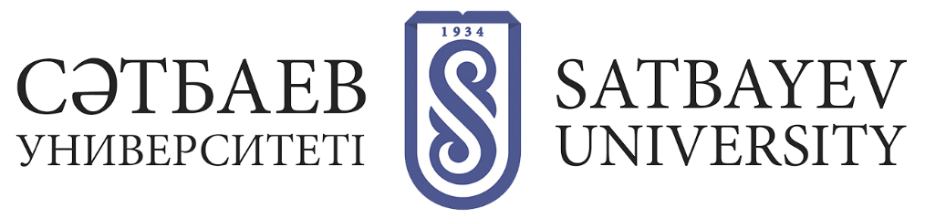
THE PROCESS OF ENTERING THE DOCTORAL PROGRAM
AT SATBAYEV UNIVERSITY

Persons with a "master's" degree and at least nine (9) months of work experience are admitted to the doctoral program.
Persons entering the doctoral program, provide to the Admissions Committee and (or) through the portal package of documents.
Acceptance of applications for doctoral doctoral program KazNRTU held Admissions Committee KazNRTU and (or) through the information system NTC in the following terms:

Acceptance of applications and registration in the information base of NCT:
- from July 3 to August 3, 2022;
- from 5 to 18 November 2022.

Entrance exams:
- August 4 through August 20, 2022;
- November 19 to December 11, 2022.

Doctoral enrollment:
- Before Aug. 28;
- December 26 to January 10, 2023.

1 STEP- To apply for the Doctoral Entrance Examination, you must:

1) Go to app.testcenter.kz and select an interface language;
2) Register in the application system by e-mail (in the letter received from the National Testing Center, be sure to confirm the e-mail);
3) to authorize through the received login and password in the application system (do not delete the letter, where the login and password are specified);
4) specify the IIN and click on the search button (the full name comes out automatically), specify the contact phone number;
5) go to the tab "Apply" and select "Postgraduate education";
6) select the required type - entrance exams;
7) fill in the data for registration;
8) confirm familiarization with the rules of entrance exams;
9) select the method of payment and make payment for the exam. After successful completion of all stages, a message will be displayed: "Application has been submitted successfully!
The applicant independently selects the city to take the test. If the applicant needs to make changes to the submitted application (test city, group of educational programs, test language), he/she has the opportunity to edit before closing the application database. To do this, it is necessary:
1) go to the "My History" tab;
2) open the application and click the "Edit Application" button;
3) make changes;
4) after editing click on the "Save" button.

Information about the location and time of the exam will be available on the personal account of the applicant.

2-Step- After submitting an application to participate in the entrance exam, you need to come to the Office for Academic Affairs (University) to confirm the international certificate of foreign language skills and gain admission to the entrance exam. Register online in the portal of the University (satbayev.hero.study).

When applying to the Admissions Committee of Satbayev University, the applicant for doctoral studies provides the following package of documents:
1) an application to the Rector;
2) a document of education (original);
3) identity document (required for identification);
4) certificate confirming fluency in English;
5) certificate of passing the state language examination (KAZTEST), issued by the NCT (any level);
6) a medical certificate on the form 075/ in electronic format, approved by order № КР DCM-175/2020).
7) Six photographs 3x4 centimeters in size;
8) a personal personnel sheet or other document confirming employment, certified by the personnel service at the place of work;
9) a list of scientific and scientific-methodological works (scientific publications, research plan, essays and other documents) for the last 3 calendar years;
10) military registration certificate or military ID (for young men).
Documents listed in subparagraphs 4) and 8) are provided in originals and copies, after verification of which originals are returned to the applicant.
If you submit an incomplete list of documents referred to in this paragraph, the selection committee does not accept documents from applicants.

When applying through the portal of the National Testing Center:
1) a request in the form of an electronic document signed by the applicant's EDS;
2) electronic justification of the planned dissertation research, agreed with the proposed domestic or foreign scientific advisor;
3) electronic document on education;
4) electronic certificate of passing the English language test;
5) certificate of passing the state language test (KAZTEST), issued by NCT (any level);
6) a digital photo of 3x4 centimeters in size;
7) a medical certificate on the form 075/ in electronic format, approved by Order No. ҚР ДСМ-175/2020).
8) an electronic document confirming the employment activity;
9) List of scientific and scientific-methodological works (scientific publications, research plan, essays and other documents) for the last 3 calendar years. When applying through the portal the applicant is sent a notice of acceptance of the request for the provision of the state service in the form of an electronic document certified by EDS in the "personal account".
10) Certificate of enlistment or military ID (for young men).
The applicant is issued a receipt of receipt of documents.

3 - STEP- When applying to the University entrant chooses 1 University and 1 SEP for admission.

Applicants must have a "master's" degree, as well as work experience of at least nine (9) months.
For admission to the doctoral program a prerequisite is the possession of an international certificate confirming knowledge of the English language in accordance with the common European competences:
English: IELTS Academic - at least 5.5 points;
TOEFL IBT - at least 46 points;
TOEFL PBT - not less than 453;
- TOEFL ITP - at least 460 points;
- German: DSH (Niveau B2/level B);
- TestDaF-Prufung (Niveau B2/level B2);
- French: TFI - at least level B2 in the reading and listening sections;
- DELF - level B2;
- DALF - B2 level;
- TCF - at least 50 points.

-Deutsche Sprachpruefung fuer den Hochschulzugang (DSH, Niveau B2/level B2);
-Diplom ed'Etudesen Langue française (DELF, level B2);
-Diplome Approfondi de Langue français (DALF, level B2);
-Test de connaissance du français (TCF - at least 50 points);
TestDaF-Prufung (Niveau B2/level B2).
Individuals with the TOEFL ITP (Test of English as a Foreign Language Institutional Testing Program) will take an additional English language proficiency test prior to taking the doctoral entrance examination

The computerized doctoral entrance exam consists of:
1) essay writing;
2) a doctoral readiness test;
3) the answers to the examination questions regarding the profile of the group of the educational program;
4) the interview takes place in an online format at the selected university before the entrance exams in the blocks "Essay Writing", "TGO" (Test of Readiness for Doctoral Studies) and "Answers to Examination Questions on the profile of the group of educational programs".

4- STEP-Receiving the results and writing an application for admission to doctoral studies.

To study in doctoral state educational order on a competitive basis are enrolled persons who scored at least 75 points at the entrance exam. In the case of the same indicators of competitive scores, preference for enrollment in doctoral studies is given to those who have the highest score of the entrance exam on the profile of the group of educational program.

Then scores for the essay, scores for the test of readiness to study, scientific achievements relevant to the profile of the educational program are taken into account: scientific publications, including those in ranked scientific publications, which are in the 1st, 2nd quartile according to Journal Citation Reports database Web of Science of Clarivate Analytics for the last 3 calendar years; certificates of scientific developments; certificates of awarding scientific scholarships, grants; certificates / diplomas for participation in scientific conferences and competitions.
Enrollment of persons to the Doctoral studies is carried out on the basis of international certificate confirming foreign language proficiency in accordance with the Common European Framework of Reference (standards) and the results of the entrance exam on the profile of the group of educational programs of doctoral studies and who have collected at least 50 points out of a possible 100 points.
Admission of foreigners to doctoral programs is carried out on a paid basis on doctoral programs. Obtaining by foreigners on a competitive basis in accordance with the state educational order of free postgraduate education is determined by international treaties of the Republic of Kazakhstan.
Submit original copies of necessary documents to the university at the address:
Satpayev, 22, Main academic building, entrance from the side of Baitursynov Street.

The work schedule of Admissions Office:
Mon-Fri: 09:00-18:00.
Saturday: 09:00-14:00
Phone numbers of admission committee:
+7 (727) 292 77 79; +7 (727) 292 73 01

