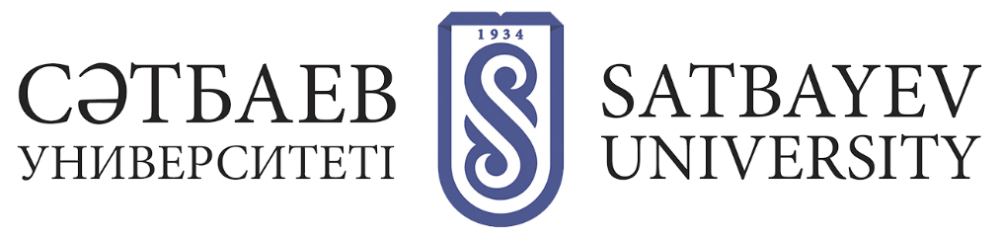

REINSTATEMENT TO THE NUMBER OF DOCTORAL STUDENTS FOR PRE-DEFENSE AND DEFENSE OF THE DOCTORAL DISSERTATION

Doctoral students of past graduates, who did not come to the defense in time, after the expiration of the term for defense on a free basis (i.e., within two years after expulsion) must be reinstated to the number of doctoral students, to undergo pre-defense and defense.
The doctoral student should write an application to the supervising Vice-Rector with a request to restore him/her to the number of doctoral students for pre-defense and defense, indicating the topic of dissertation research and supervisors. After approval by the Academic Council of the University, an order is issued.
The following documents are attached to the application:
1) application to the supervising vice-rector (pre-signed by the domestic supervisor, head of department, director of the institute);
2) orders on enrollment, dismissal, approval of the topic and scientific advisors;
3) excerpt from the minutes of the department meeting, excerpt from the meeting of the Academic Council of the Institute
In case of expiration of 3 years after graduation doctoral student is allowed to defense only after re-approval of the scientific substantiation of the dissertation research (research proposal), doctoral student should write an application to the supervising Vice-Rector with a request to restore him/her to the number of doctoral students for re-approval of the scientific substantiation of the dissertation research on the topic of the dissertation and for pre-defense and further defense. After the doctoral student provides a statement, an extract from the meeting of the department, the Academic Council of the Institute for submission to the Academic Council of the University. The following documents are attached to the application:
1) orders on enrollment, dismissal, approval of the topic and scientific advisors;
2) excerpt from the minutes of the department meeting, excerpt from the meeting of the Academic Council of the institute
After approval by the Academic Council of the University, the Department of Doctoral Studies on the basis of the extract of the RS issues an order on the reinstatement and approval of the scientific justification.

